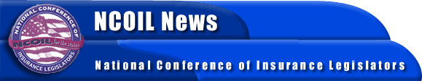

FOR IMMEDIATE RELEASE
CONTACT:
Candace Frick
Susan Nolan
NCOIL National Office
(518) 449-3210

CONSUMER PROPOSAL ENCOURAGES PARTICIPATION
AT NCOIL MEETINGS

Albany, New York, November 24 ─ Consumers interested in attending meetings of the National Conference of Insurance Legislators (NCOIL) might now attend registration-free thanks to a proposal adopted during last week’s NCOIL Annual Meeting in Santa Fe, New Mexico.
The proposal, sponsored by NCOIL Vice President Rep. Craig Eiland (TX), waives the registration fees of up to three (3) consumer advocates per NCOIL meeting and provides that the NCOIL president has ultimate authority to chose whose fees will be waived. Funded consumers of the National Association of Insurance Commissioners (NAIC) will be among those considered, as will advocates located in the area in which an NCOIL meeting will be held.
The proposal outlines several eligibility requirements for a registration-fee waiver, including knowledge of relevant insurance issues and support of a substantial constituency, as determined by NCOIL. The program is scheduled for review during the 2004 NCOIL Annual Meeting.
NCOIL is an organization of state legislators whose primary interest is insurance legislation and regulation. Many legislators active in NCOIL are chairs, vice chairs, or members of the committees responsible for insurance in their respective state houses across the country.
For more information, please contact the NCOIL National Office at (518) 449-3210.

-30-

