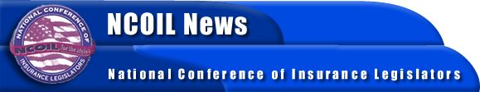

MEDIA ADVISORY
CONTACT:
BOB MACKIN
NCOIL National Office
(518) 449-3210

NCOIL PRESIDENT ANNOUNCES 2003 COMMITTEE CHAIRS

Albany, New York, January 27, 2003 ? National Conference of Insurance Legislators (NCOIL) President Rep. Kathleen Keenan (VT) today announced the appointments of the following 2003 Committee chairs:
• Health Insurance: Rep. Brian Kennedy (RI)
• International Insurance Issues: Rep. Mark Young (VT)
• Life Insurance: Sen. James Seward (NY)
• Property-Casualty Insurance: Rep. George Keiser (ND)
• State-Federal Relations: Sen. Neil Breslin (NY)
• Workers’ Compensation Insurance: Assem. Nancy Calhoun (NY)
Rep. Keenan noted that “Given the unprecedented political and insurance marketplace realities, the coming year will be vitally important for state legislators and NCOIL.” Issues including the hardening of the commercial and personal insurance markets, the growing concerns over availability and affordability of health insurance, the push by some to erode the state regulatory system, and the ongoing threat of terrorism will require NCOIL leadership in 2003, Rep. Keenan said.
Keenan added that “state lawmakers must focus on streamlining the current system of insurance regulation so it becomes more uniform and so it effectively protects consumers, fosters competition, and does not place insurance providers at a competitive disadvantage with other sectors of the financial services industry.”
NCOIL is an organization of state legislators whose main area of public policy concern is insurance legislation and regulation. Many state legislators active in NCOIL either chair or are members of the committees responsible for insurance legislation in their respective state houses across the country.
For more information, please contact the NCOIL National Office at (518) 449-3210.

