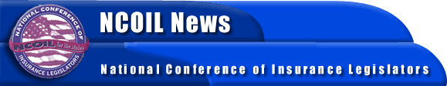

FOR IMMEDIATE RELEASE
CONTACT: BOB MACKIN (518) 449-3210

NCOIL ANNOUNCES SPRING MEETING AGENDA
ALBANY, NY, JANUARY 19, 2000- Recent events in the insurance world have changed all the rules, or at least, many of the expectations. The new presidential administration, the release of federal Health and Human Services (HHS) regulations, and the growing evidence of the need for regulatory reform are among the issues contributing to the current wave of activity in the insurance business. At the NCOIL Spring Meeting, legislators, regulators, and members of the industry from all over the country will meet to discuss and help forward the states’ role in the new marketplace. The meeting will be held at the Hilton Head Oceanfront Resort, Hilton Head Island, South Carolina, from March 1 through 4, 2001.
Legislators will address issues that include: privacy, proposed deregulation of car and homeowners insurance prices, the high cost of health care and pharmaceuticals, producer licensing, international insurance issues, and natural disaster insurance.
Topping the agenda will be a hearing on personal lines deregulation by the NCOIL Property-Casualty Insurance Committee. The hearing will produce comments on personal lines form and rate filing from state legislators, state insurance regulators, insurance industry representatives, consumer advocates, and other interested parties. A notice of hearing and request to testify form are available on the NCOIL Web site.
NCOIL also anticipates extensive discussion on its newly adopted Financial Information Privacy Protection Model Act, which legislators are filing in their legislatures across the country. The NCOIL Privacy Task Force has scheduled a meeting in Hilton Head to address the newly adopted Model, and to entertain proposed substantive amendments. The NCOIL Office must receive amendments to the Model no later than February 1, 2001.
NCOIL has also planned three general session panel discussions on international reinsurance issues, the high cost of health care and pharmaceuticals, and federal flood insurance programs.
Information and registration for the Spring Meeting are now available on the NCOIL Web site at www.ncoil.org.

