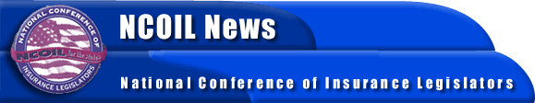

FOR IMMEDIATE RELEASE

CONTACT:

TIM TUCKER

NCOIL Washington Office
(202) 220-3014

ttucker@ncoil.org

NCOIL ESTABLISHES GREATER PRESENSE IN WASHINGTON

Washington, DC, October 17, 2002— NCOIL President, State Senator William J. Larkin, Jr., of New York announced today that NCOIL has opened its Washington, DC office. Sen. Larkin said the challenges facing state regulation of insurance and the political realities in Washington were the impetus for creating the Washington office.
In announcing the creation of the new office, Sen. Larkin said, “The push for the creation of an optional federal chartering mechanism for insurers, as well as ongoing state efforts to modernize insurance product approval regulation, establishment of reciprocity ⎯ and ultimately uniformity ⎯ for company and producer licensing, and reform of market conduct regulation all point to the need for the clear articulation of the views of state legislators in Washington and on Capitol Hill.”
Timothy Tucker will head the office and will serve as the organization’s representative before Congress and federal executive branch agencies. Mr. Tucker will be responsible for communicating NCOIL’s position on insurance issues to members of Congress and their staffs.
NCOIL's Washington Office is located at: 601 Pennsylvania Avenue, NW, Suite 900 – South Building, Washington, DC 20004. The office can be reached by telephone at (202) 220-3014 or by fax at (202) 220-3016. NCOIL’s National Office will remain in Albany, New York.
NCOIL is an organization of state legislators whose main area of public policy concern is insurance and insurance regulation. Legislators active in NCOIL either chair or are active members of the committees responsible for insurance in their respective legislative houses across the country.
# # #

