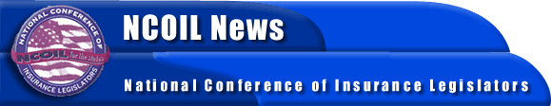

FOR IMMEDIATE RELEASE
CONTACT:
Bob Mackin
Susan Nolan
NCOIL National Office
(518) 449-3210

GOVERNOR RICHARDSON TO NCOIL: STATE LEGISLATORS MUST ADDRESS HEALTHCARE REFORM

Albany, New York, November 24 ─ The federal government has punted when it comes to healthcare, and it is up to the states to resolve the issue, New Mexico Governor Bill Richardson said Friday before an overflow luncheon audience.
The Governor told state legislators participating in the Annual Meeting of the National Conference of Insurance Legislators (NCOIL) that Congress’ inability to resolve Medicare reform and other health issues meant that state lawmakers needed to consider new approaches to healthcare and insurance reform.
The Governor said specifically that lawmakers need to consider state authorization of such intended remedies as purchasing cooperatives and tax breaks for employers who provide healthcare insurance.
Close to 300 state legislators, other government representatives, and insurance-industry and other representatives gathered at the Eldorado Hotel in Santa Fe, New Mexico, for the NCOIL meeting.
NCOIL is an organization of state legislators whose primary area of public policy concern is insurance. Many legislators active in NCOIL serve in leadership positions, chair, vice chair, or are active members of the committees responsible for insurance in their respective state houses across the country.
For more information, please contact the NCOIL National Office at (518) 449-3210.

-30-

