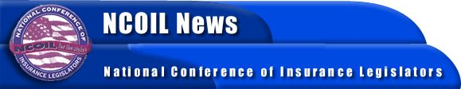

FOR IMMEDIATE RELEASE
CONTACT:
Tim Tucker
NCOIL Washington Office
(202) 220-3014

NCOIL CONTINUES INSURANCE REGULATORY MODERNIZATION PUSH; LEGISLATORS TO DRAFT MARKET CONDUCT MODEL LAW

Albany, NY, July 18, 2003─ The National Conference of Insurance Legislators (NCOIL) will begin drafting a market conduct regulation model law designed to better protect insurance consumers and bring greater uniformity to this key regulatory function.
NCOIL President Rep. Kathleen Keenan (VT) said, “Market conduct reform is a cornerstone of insurance regulatory modernization. Creating a more streamlined and uniform insurance market conduct regulatory regime has been a top priority of NCOIL. The current system of market conduct regulation does not adequately focus on specific problems in the insurance marketplace, but rather on arbitrary factors.
“Over the past four years, NCOIL and the Insurance Legislators Foundation (ILF), NCOIL’s research and education arm, have examined market conduct regulation and issued two comprehensive reports. Those studies found that only two states have statutes addressing market conduct examinations. NCOIL believes that the development of a model law is necessary to create meaningful and lasting market conduct regulation reform,” said Rep. Keenan.
“NCOIL has set an aggressive timeline for work on this important model and we intend to have a model law ready for consideration at the Annual Meeting,” concluded Rep. Keenan.
The NCOIL Annual Meeting will take place November 20 through 23 at El Dorado Hotel in Santa Fe, New Mexico.
NCOIL is an organization of state legislators interested in insurance legislation and regulation. Many state lawmakers active in NCOIL either chair or are members of the committees responsible for insurance legislation in their respective houses across the country.

-30-

