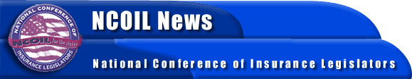

NEWS ADVISORY
FROM:
BOB MACKIN, NCOIL EXECUTIVE DIRECTOR
518-449-4698, NCOIL National Office
617-236-2000, Sheraton Boston after July 11

NCOIL HOLDS SUMMER MEETING IN BOSTON
July 10, 2002, Boston, Massachusetts – Critical regulatory issues affecting the price and availability of insurance in U.S. and international markets will be up for discussion and debate when state legislators and interested parties from across the country and overseas gather for the Summer Meeting of the National Conference of Insurance Legislators (NCOIL) at the Sheraton Boston this weekend (Thursday, July 11 to Sunday, July 14.)
More then 260 state legislators, legislative staff, insurance commissioners, and insurance industry representatives are expected to attend the meeting. The lawmakers will address issues that relate to auto safety and car insurance rates, genetic information, international trade restrictions, credit scoring, and class action law suits. Legislators will address such questions as:
Will use of certified aftermarket crash parts not made by the original car manufacturers help lower car insurance costs? How do such parts compare in quality to those produced by major automobile makers? Are such parts safe?
How far may insurers go in their use of genetic information that could indicate the likelihood of terminal illness?
Should state legislature ease present rules that require large security deposits by overseas-based reinsurers who do business here?
Should state laws allow insurers to use an individual's credit history in underwriting and pricing his or her insurance policy?
-MORE-
NCOIL – 2
What steps should life insurance sales representatives take to determine that a policy suits the needs of a consumer?
Should states curb alleged abuses related to class action lawsuits?
NCOIL is an organization of state legislators whose primary area of public policy concern is insurance. Legislators active in NCOIL either chair or are active members on the committee responsible for insurance in their respective legislative houses in states across the country.
A detailed program is available on request.
# # #

