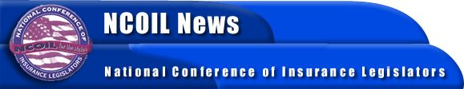

NEWS ADVISORY FOR CHARLESTON MEDIA
CONTACT:
BOB MACKIN
SUSAN NOLAN
518-449-4698
843-577-2400 AFTER FEBRUARY 26

Charleston, SC, February 22, 2002 -- Consumer protection issues will dominate debate when state legislators from across the country gather at the Mills House here for the Spring Meeting of the National Conference of Insurance Legislators (NCOIL), February 28 through March 3.
The meeting will also focus on the potential loss of state revenue that could result from initiatives in Congress that would allow insurers to operate under federal regulation, instead of state regulation as they now do.
More than 230 state law makers, industry and consumer group representatives and other interested parties will participate.
The lawmakers, among others things, will consider model bills that address such questions which range in subject from auto body repairs and genetic discrimination to insurance in an age of terror. The legislators will focus, for example, on such questions as:
-- should state laws require auto repair shops to tell car owners when crash parts don't come from the original manufacturer?
-- will car insurance and auto repairs cost less if crash parts are not those of the original manufacturer?
-- should state laws bar life insurers from using genetic information to deny or cancel coverage?
-- what is the impact of the events of September 11 on the cost and availability of insurance in South Carolina and other states?
-- what would be the financial impact of federal insurance company chartering legislation that threatens continuance of the $10 billion the states now receive in insurance premium taxes? South Carolina realized $85.1 million in such taxes in 2000.
NCOIL is a non-partisan organization of state legislators who chair or are active members of the committees responsible for insurance regulation in their respective legislative houses across the country.
###
NOTE TO EDITORS: You can receive a detailed program of the NCOIL Charleston meeting by calling: 518-449-4698.

