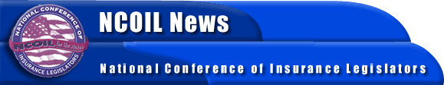

FOR IMMEDIATE RELEASE

CONTACTS:

BOB MACKIN
SUSAN NOLAN
(518) 449-3210 -- NCOIL NATIONAL HEADQUARTERS

NCOIL PRESIDENT URGES ENACTMENT OF FEDERAL
BACKSTOP TO COVER TERRORISM
Albany, NY, December 20, 2001 -- New York State Senator William J. Larkin, Jr., President of the National Conference of Insurance Legislators (NCOIL), today sent a letter to members of the U.S. Senate Committees on Commerce, Science, and Transportation and on Banking, Housing, and Urban Affairs. The letter urges enactment before the end of the year of a federal reinsurance backstop to cover terrorism. The Senate is presently considering three bills (S. 1743, S. 1744, and S. 1751) that would establish a backstop.
NCOIL is an organization of state legislators whose main area of public policy concern is insurance legislation and regulation. Many legislators active in NCOIL either chair or are members of the committees responsible for insurance legislation in their respective state houses across the country.
A copy of the letter is attached.

